Name: Aniruddha Bera
Module 2 Assignments:
Inventory Mgt System :
Data structure implemented: HashMap
Reason: A HashMap was chosen because each product has a unique product ID, which can be used as the key. HashMap provides O(1) average-time complexity for insertion, lookup, update, and deletion operations. In contrast, an ArrayList would require O(n) time to search for a product before updating or deleting it. Therefore, HashMap is more efficient and scalable for managing large inventories.
Time complexity : update , add, delete O(1)
Code :
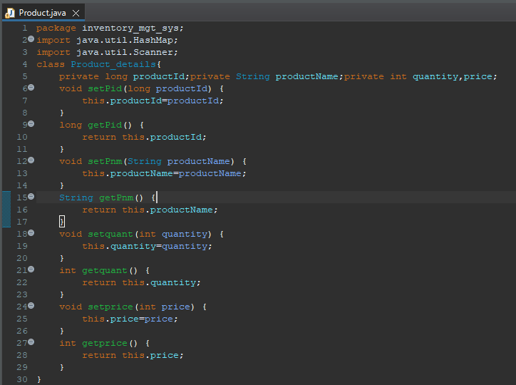
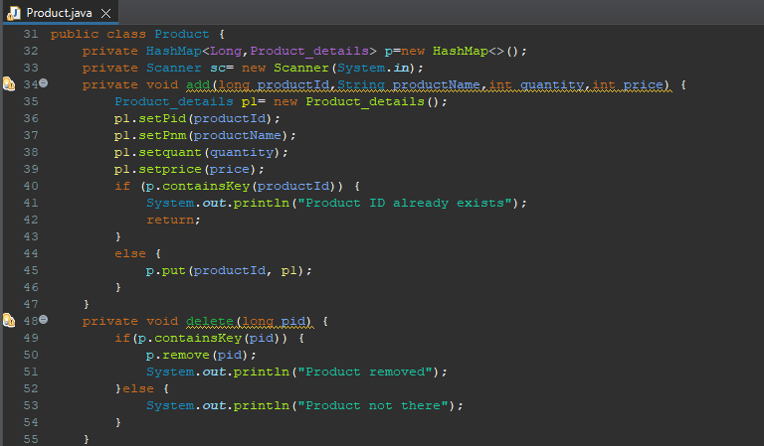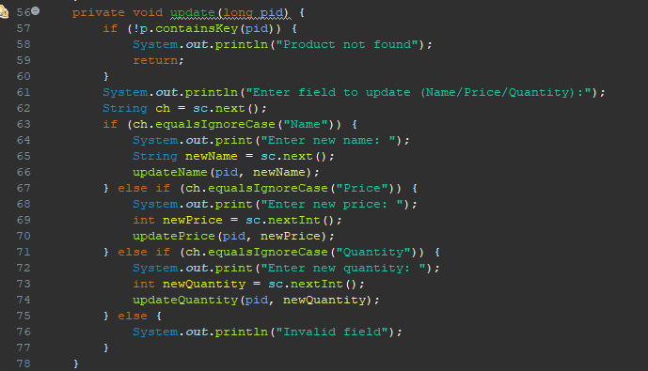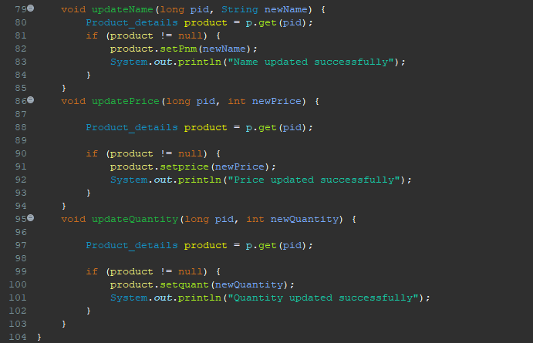
- Ecommerce Search:
Data structure implemented: Arrays
Code :
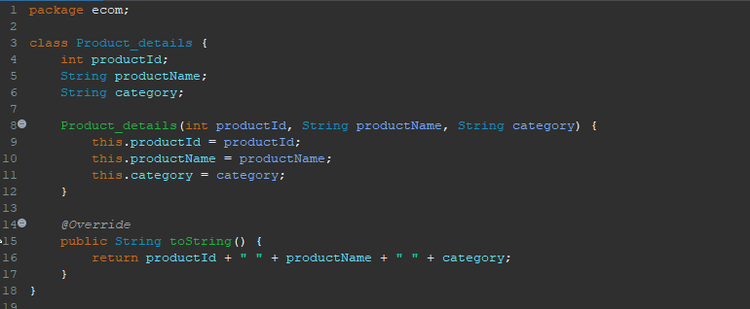
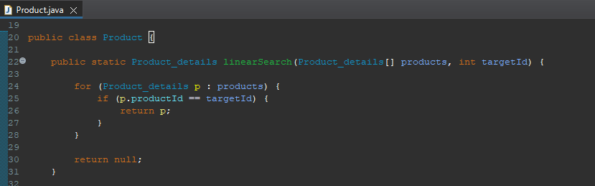
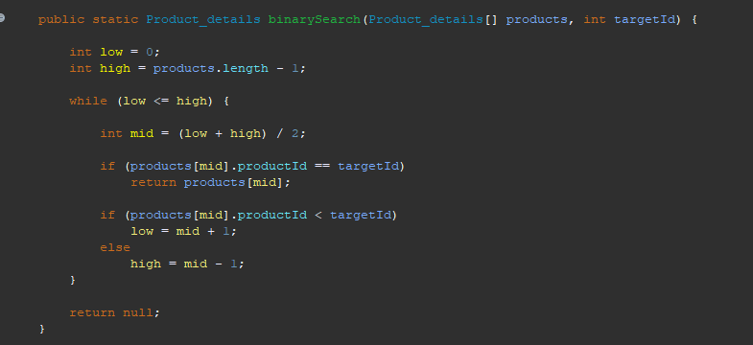
Here the linear search takes a time complexity of O(n) in the worst case scenario and the binary search take O(log n) time complexity . Hence the Binary Search technique is most suited here .

- Sorting customer orders:
Code:
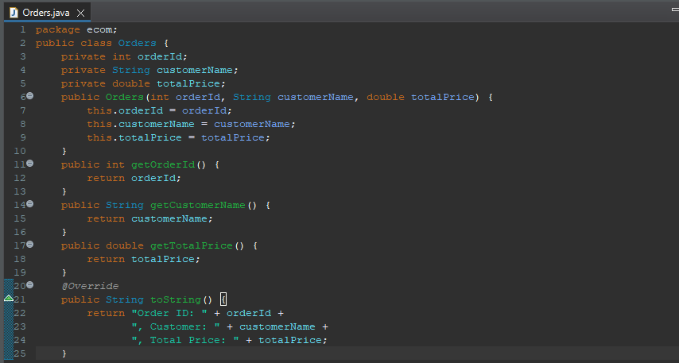
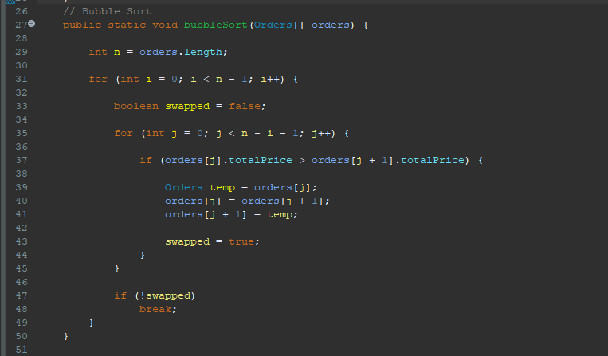
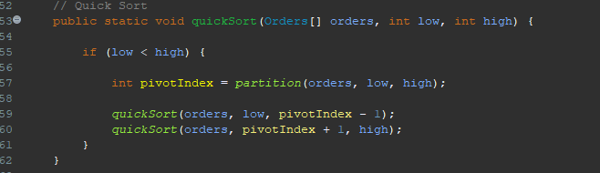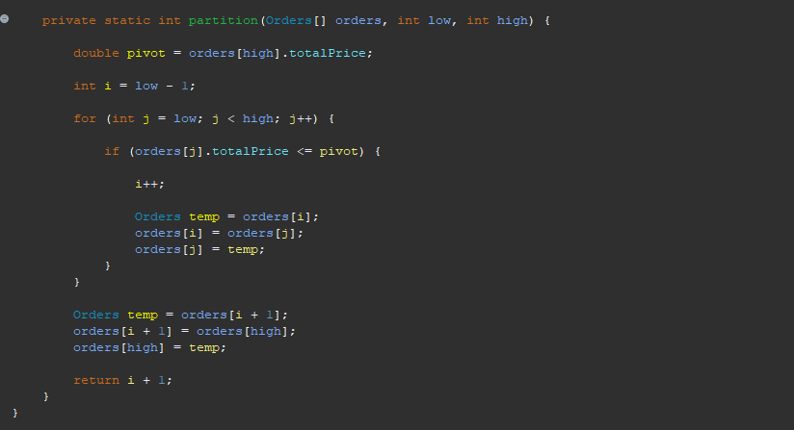

Bubble Sort repeatedly compares adjacent elements, making it inefficient for large datasets.

Quick Sort divides the array into smaller partitions and sorts them recursively.

Average performance of Quick Sort is O(n log n), which is much faster than Bubble Sort's O(n²).

E-commerce platforms may process thousands of orders, making Quick Sort a better choice for scalability and performance.
- Bubble Sort repeatedly compares adjacent elements, making it inefficient for large datasets.
- Quick Sort divides the array into smaller partitions and sorts them recursively.
- Average performance of Quick Sort is O(n log n), which is much faster than Bubble Sort's O(n²).
- E-commerce platforms may process thousands of orders, making Quick Sort a better choice for scalability and performance.

- Employee Mgt System :
An array stores elements in contiguous memory locations.
Code :
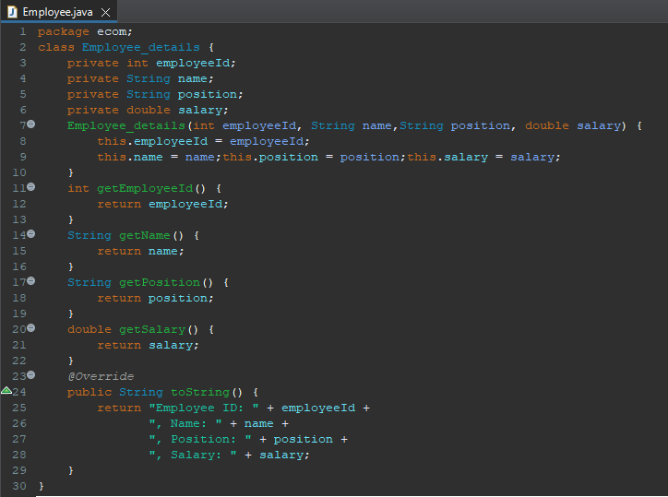
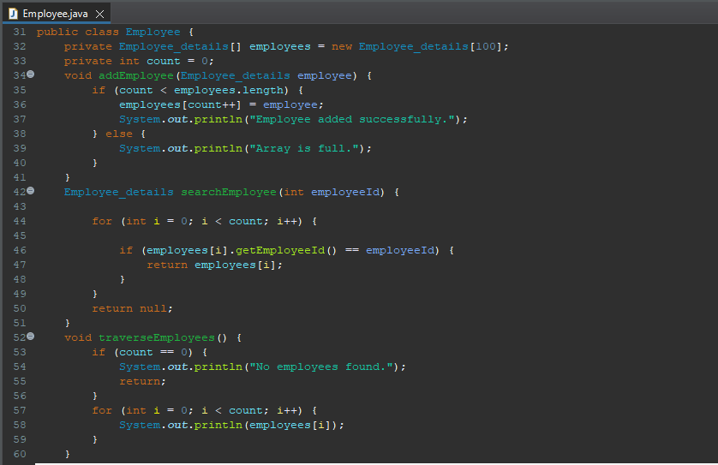
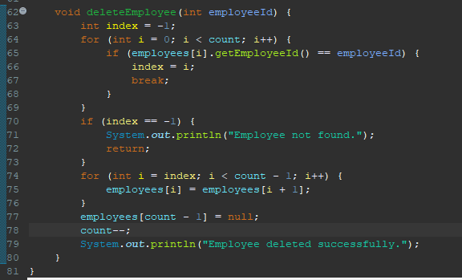
Arrays are suitable when:
- Number of records is known.
- Fast index-based access is needed.
- Memory efficiency is important.
- Dataset size is relatively small.
Here the arrays should not be used as they offer no flexibility and scalability as they are of predefined size
Time complexities : search ,traverse, delete uses O(n) while add uses O(1) .
- Task Mgt System :
Code :
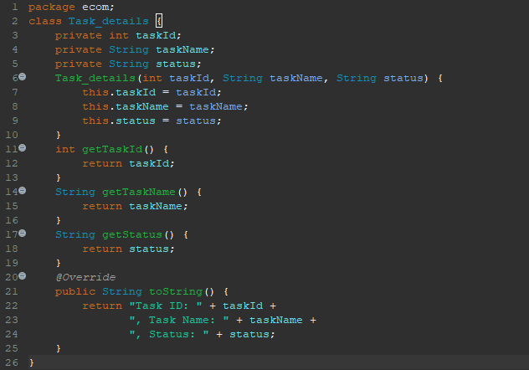

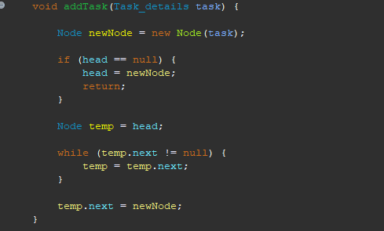
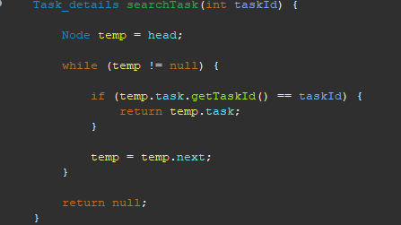
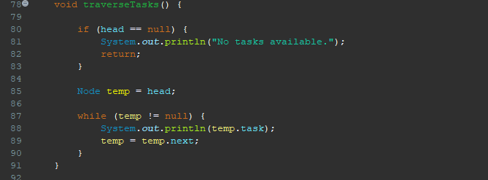
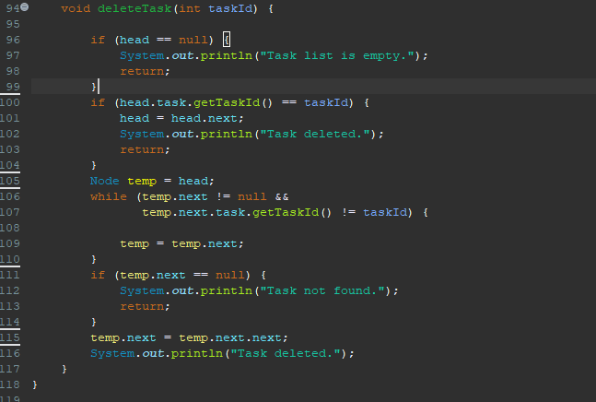
A singly linked list and a doubly linked list are both dynamic linear data structures made up of connected nodes. The primary difference is that singly linked list nodes contain a data field and one pointer (to the next node), whereas doubly linked list nodes contain a data field and two pointers (to both the next and previous nodes)
Every operation here is O(n) .
- Advantages over arrays include :
Dynamic size of linked list make it scalable and flexible
- Memory efficient
- Library Mgt System :
Linear search :
- Start at the first element (index 0) of the collection.
- Compare the current element to your target value.
- If they match, return the index of that element.
- If they do not match, move to the next element.
- Repeat steps 2-4 until you find a match or reach the end of the collection.
- If the collection ends without a match, return -1 to signal the item was not found.
Binary search :
- Calculate Midpoint: Find the middle index of the current window.
- Evaluate Target: Compare the midpoint value to your target.
- Match: If the midpoint value equals the target, return its index.
- Discard Left: If the target is greater, shift the low pointer to mid + 1.
- Discard Right: If the target is smaller, shift the high pointer to mid - 1.
- Repeat: Continue until the target is found or low exceeds high.
Code :
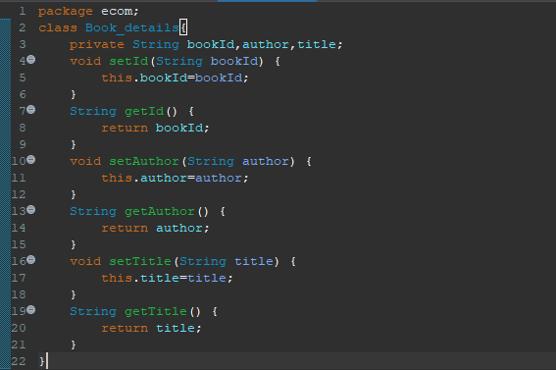
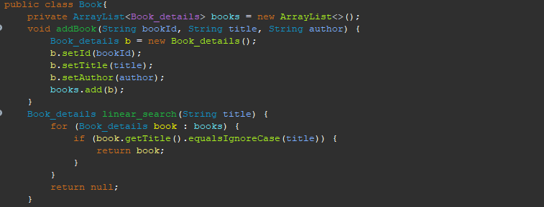
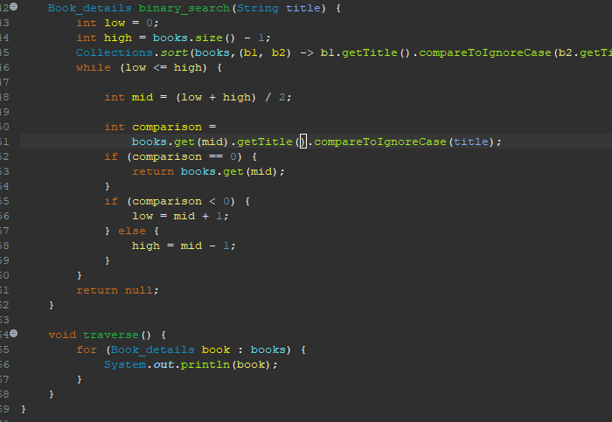
Use Binary Search when ---
- Data is sorted by title.
- Number of books is large.
- Faster searching is needed.

- Recursion :
Recursion is a programming technique where a method calls itself to solve a problem.
Instead of solving the entire problem at once, the problem is broken into smaller versions of itself until a simple case is reached.
Some problems are naturally defined in terms of smaller versions of themselves.Instead of writing complex loops and managing variables manually, recursion lets us express the solution more directly. Here recursion helps us solve the problems efficiently .
Pseudocode of the algorithm :
Method recur(int time){
If(time == bas_case_time) {
Return ;
} else {
Operations to predict value as a function of time
Return recur(time-1)
}
}
Time complexity : T(n) = T(n-1) + O(1)
Optimizations :
The above recursion is already efficient because each recursive call is made only once. However, recursion uses additional stack memory. To avoid excessive computation and stack usage ,we can use iterations and any direct formula if available . (to decrease the stack space taken which is O(n)) .

